Jason Holman and Boden Archuleta Iteration 1 Database Design

1.

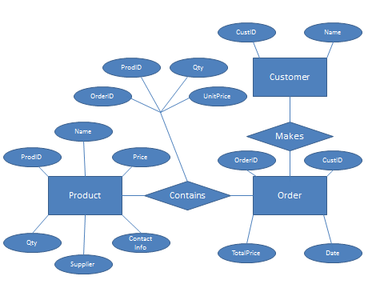

2. Product

|  |  |  |  |  |  |
| --- | --- | --- | --- | --- | --- |
| **ProdID(key)** | **Name** | **Price** | **Qty** | **Supplier** | **Contact info** |
| 100 | Apple | 1.99 | 5 | Apple | Apple@apple |
| 101 | Orange | 2.50 | 7 | Orance co | orange@orange |

Customer

|  |  |  |
| --- | --- | --- |
| **CustID(key)** | **Name** | **isValCust** |
| 1000 | John Smith | True |
| 1001 | Jane Doe | False |

Order

|  |  |  |  |
| --- | --- | --- | --- |
| **OrderID(key)** | **CustID** | **TotalPrice** | **Date** |
| 900 | 1000 | 50.24 | 2009-10-07 |
| 901 | 1001 | 47.98 | 2016-12-25 |

Contains

|  |  |  |  |
| --- | --- | --- | --- |
| **OrderID(key)** | **ProdID(key)** | **Qty** | **UnitPrice** |
| 900 | 100 | 8 | 1.99 |
| 900 | 101 | 9 | 2.50 |
| 901 | 100 | 4 | 1.99 |

Employees

|  |  |  |  |  |
| --- | --- | --- | --- | --- |
| **EmployeeID(key)** | **Username** | **Code** | **ImageURL** | **Status** |
| 001 | Bob | 123456 | Image.com | True(Manager) |
| 002 | Sally | Password | Image2.com | False(Cashier) |

3. create table PRODUCT (

ProdID int not null primary key,

Name char(30) not null,

Price number not null,

Qty int not null,

Supplier varchar(60) not null,

ContactInfo varchar(60) null);

create table CUSTOMER (

CustId int not null primary key,

Name char(30) not null);

create table ORDER (

OrderID int not null primary key,

ProdID references Product(ProdID)

On delete cascade,

TotalPrice number not null,

Date DATE not null);

create table CONTAINS (

OrderID references Order (OrderID)

On delete cascade,

ProdID references PRODUCT (ProdID)

On delete cascade,

Qty int not null,

UnitPrice DECIMAL(10, 2) not null,

primary key (CustID, ProdID));

create table employees(

EmployeeID int not null primary key,

Username varchar(30) not null,

Code varchar(30) not null,

ImageURL varchar(100) not null,

Status boolean not null);